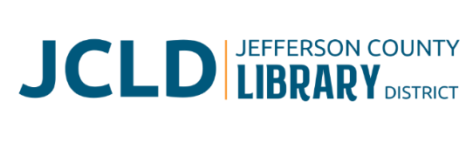
BOARD OF DIRECTORS MEETING
Tuesday, April 8, 2025 @ 4:30 pm
241 SE 7th St, Madras, OR 97741

Minutes
Board members present: Susan Stovall, Tiffany Turo, Tess Ballard, Karen Esvelt
Staff members present: Jane Innes, Laura Jones, Kristin Peterson, Tom Hawk

- Call to Order
Chairperson Susan Stovall called the meeting to order at 4:35 pm.
- Acceptance of Agenda and Establishment of a Quorum
A quorum was established with four Board members present. Tess Ballard moved and Karen Esvelt seconded to accept the agenda with flexibility. Motion carried.

- Public Comment - None
- Presentations
Tom Hawk, maintenance for JCLD, updated the board on the status of 234 SE 7th St and presented a spreadsheet with all the contractor bids for repairing and/or tearing down the house.
- Review/Approval of Minutes – March 11, 2025 Board Meeting
No questions/discussion. The minutes stand approved as presented.
- Finance Report - Monthly financials as of March 31, 2025
Jane Innes discussed her concerns about income. We are below the projected amount of Jefferson County tax revenue. We are under our budgeted expenses, so we should still be in good shape for this fiscal year. Innes will be asking the staff to curtail any unnecessary spending for the remainder of the fiscal year. The board members asked questions. Innes also discussed the grant funds that will be paying for changing our catalog interface to Vega. Tiffany Turo moved, Esvelt seconded to accept the financials as presented. No further discussion, motion carried.

- Old Business
  - Revision of Budget Assumptions – Innes discussed some of the changes from her original budget assumptions based on decreased revenue projection.
  - Bond/Building expansion update – we will be scheduling open houses at the library. Turo and Stovall talked about yard signs and mass mailing postcards. The facebook page for “Grow Our Library” is live and being managed by Turo, as president of the PAC.
- New Business
Policy Monitoring – The Board agreed that they are in compliance with the following policies:
    - Executive Limitations: Financial Condition and Activities/Financial Planning and Budgeting
    - Executive Limitations: Treatment of Library Users
- Library Activities Report and Update
Innes and Laura Jones went through the activities report with the Board. They highlighted the upcoming Coffee Cuppers event at the library on April 18.

- Director Evaluation – Innes updated the status of goals in the Strategic Plan. Jones also talked about the way ahead for the Summer Reading Program and other programming priorities. The Board will meet in Executive Session until next month to discuss the Library Director’s annual performance review and contract in accordance with ORS 192.660(2)(i).

- Ending Remarks

- Adjourn

Stovall adjourned the meeting at 6:02 pm.

Respectfully Submitted,

Kristin Peterson
JCLD Executive Assistant and Acting Secretary to the Board

