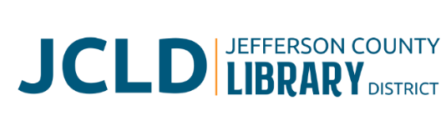
BOARD OF DIRECTORS MEETING
Tuesday, March 11, 2025 @ 4:30 pm
241 SE 7th St, Madras, OR 97741

Minutes
Board present: Susan Stovall, Tiffany Turo, Stephen Hillis, Tess Ballard, Karen Esvelt
Staff present: Jane Innes, Laura Jones, Kristin Peterson

- Call to Order
Chair Susan Stovall called the meeting to order at 4:41pm.
- Acceptance of Agenda and Establishment of a Quorum
A quorum was established. Karen Esvelt moved and Tiffany Turo seconded to accept the agenda with flexibility. Motion carried unanimously.
- Public Comment
None
- Presentations
None
- Review/Approval of Minutes – February 12, 2025 Board Meeting
There was one correction on a name. The correction was made and minutes stand as approved.
- Finance Report - Monthly financials as of February 28, 2025.
Jane Innes expressed concern about Jefferson County tax revenue projections for the fiscal year. Lines for Genealogy PERS and taxes should be under personnel expenses rather than materials and services. Kristin Peterson will make the correction. Stephen Hillis moved and Esvelt seconded to accept the financials with corrections. Motion carried unanimously.
- Old Business
  - Take-aways from SDAO Conference
Innes got information about EnergyTrust of Oregon regarding new building. We want to get them involved in architectural plans if the bond passes. Stovall learned tips and tricks for getting in touch with legislators about funding.
  - Bond/Building expansion update
SEL 805 and SEL 803 were both submitted to Jefferson and Wasco Counties. We have a petition # for the measure.
- New Business
  - Budget assumptions and calendar. Innes discussed the assumptions she will use for budgeting for 2025-2026. The Board agreed with the assumptions.
  - Review Mission and Vision statements. The Board agreed with the mission and vision statements and made no changes.
  - Library Director evaluation packets distributed. Tess Ballard sent electronic packets to the Board members’ emails. Innes is updating the Strategic plan and Results Policy to include in the evaluation packet.
- Library Activities Report and Update

Laura Jones and Innes discussed the activities report: contract talks with DPL and CC, Unique management collection agency, changing the catalog interface to Vega Discovery, Early Literacy Kit books and financing, and check-out statistics for eBooks/eAudiobooks/cd audiobooks.

- Ending Remarks

- Adjourn

Stovall adjourned the meeting at 5:58pm.

Respectfully Submitted,

Kristin Peterson
JCLD Executive Assistant and Acting Secretary to the Board

