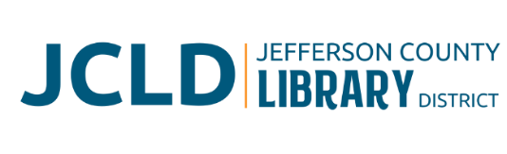
BOARD OF DIRECTORS MEETING
Tuesday, July 14, 2026 @ 4:30 pm
241 SE 7th St, Madras, OR 97741

Agenda
- Call to Order
- Acceptance of Agenda and Establishment of a Quorum
- Public Comment
- Presentations
- Review/Approval of Minutes – June 9, 2026 Board Meeting
- Finance Report
  - Monthly financials as of June 30, 2026
  - End of year financial review
- Old Business
  - Policy adoption – Results Policy
  - Finalize date for Strategic Planning session
- New Business
  - Policy Monitoring
    - Governance: Governing Style, Board Job Descriptions
    - Executive Limitations: Financial Condition and Activities, Financial Planning and Budgeting
  - Review/approve 2026-2027 Annual Calendar
  - Resolution 26-02 Corporate Signing Authority
- Library Activities Report and Update

- Ending Remarks

- Adjourn

