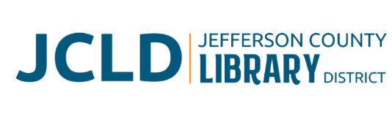
BOARD OF DIRECTORS MEETING
Tuesday, May 12, 2026 @ 4:30 pm
211 C St, Culver, OR 97741

Agenda
- Call to Order
- Acceptance of Agenda and Establishment of a Quorum
- Public Comment
- Presentations
- Review/Approval of Minutes
- April 14, 2026 Board Meeting
- Finance Report
- Monthly financials as of April 30, 2026
- Old Business
- Update on Culver branch
- New Business
- Request from JeffCo Public Health to designate library as a cleaner air & cooling space
- Policy discussion
  - Pay scale plan and policy
  - Social media policy
- Policy Monitoring
    - Governance: Global Governance Commitment
    - Executive Limitations: Treatment of Staff
- Library Activities Report and Update

- Executive Session
- Discuss Executive Director Contract Review/Renewal/Negotiation IAW ORS 192.660 (i)

- Adjourn

