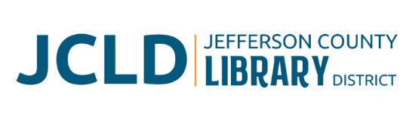
BOARD OF DIRECTORS MEETING
Tuesday, March 10, 2026 @ 4:30 pm
241 SE 7th St, Madras, OR 97741

Agenda
- Call to Order
- Acceptance of Agenda and Establishment of a Quorum
- Public Comment
- Presentations
- Review/Approval of Minutes
- February 10, 2026 Board Meeting; February 24, 2026 Special Board Meeting
- Finance Report
- Monthly financials as of February 28, 2026
- Old Business
- Governance: Board Operations policy. Review changes for adoption.
- Update from Building Committee
- Executive Director evaluation packet distributed to Board
- New Business
- Policy Monitoring
    - Governance: Annual Calendar
    - Executive Limitations: Collection Development
  - Review mission and vision statements
  - Schedule work session for Strategic Plan
- Library Activities Report and Update

- Ending Remarks

- Adjourn

