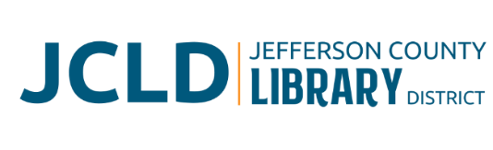
BOARD OF DIRECTORS WORK SESSION
Saturday, August 1, 2026 @ 10:00 am
Chamber of Commerce meeting room, Madras, OR 97741

Agenda

1. Introductions
2. What is Strategic Planning?
- Purpose of this Work Session
- Intended Outcomes
3. Mission and Vision Review and Validation
4. SWOT Analysis
- Current State
- Strengths | Weaknesses | Opportunity | Threat
5. Library Values
  - Non-negotiable operating principles
  - Define Customers
  - Customer Expectations/Concerns
  - Define and Prioritize Services
6. Major Goals and Objectives
- Review Board Results Policy – Refine
- Prioritize Program and Service Goals
- Define Objectives
- Budget Implications
7. Next Steps
- Staff Develops Implementation Plan
  - SMART Goals
  - Responsible personnel
- Monitor results and evaluate efficacy
8. Adjourn

Resources

- Overview of Strategic Planning
- Copy of Vision and Mission Statements
- Former Strategic Plan 2023-2025
- 2026-2027 Results Policy
- What are SMART Goals?

