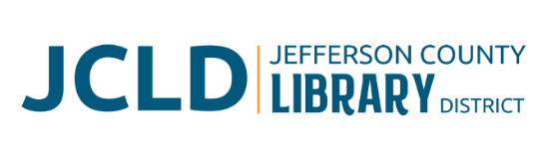
BOARD OF DIRECTORS MEETING
Tuesday, April 14, 2026 @ 4:30 pm
241 SE 7th St, Madras, OR 97741

Agenda
- Call to Order
- Acceptance of Agenda and Establishment of a Quorum
- Public Comment
- Presentations
- Review/Approval of Minutes
- March 10, 2026 Board Meeting
- Finance Report
- Monthly financials as of March 30, 2026
- Old Business
- Update from Building Committee
- Executive Director evaluation
- New Business
- Resolution 25-05: Accepting Grant Funds form the American Library Association
- Policy Monitoring
    - Executive Limitations: Financial Condition and Activities, Financial Planning and Budgeting
    - Executive Limitations: Treatment of Library Users
  - Public Meetings Law Training from SDAO (31 minutes)
- Library Activities Report and Update

- Ending Remarks

- Adjourn

