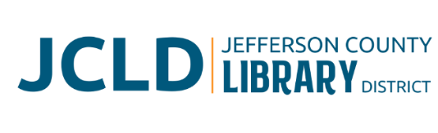
BOARD OF DIRECTORS MEETING
Tuesday, June 9, 2026 @ 4:30 pm
241 SE 7th Street, Madras, OR 97741

Agenda
- Call to Order
- Acceptance of Agenda and Establishment of a Quorum
- Public Comment
- Presentations
- Review/Approval of Minutes
- May 12, 2026 Board Meeting
- Finance Report
- Monthly financials as of May 31, 2026
- Old Business
- Policy adoption – Pay scale plan and policy
- New Business
- Elect Board officers for 2026-2027
- Review Results Policy for 2026-2027
- Library Activities Report and Update

- Executive Session
- Discuss Executive Director Contract Review/Renewal/Negotiation IAW ORS 192.660 (i)

- Adjourn

