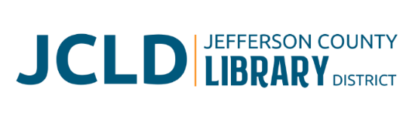

**BOARD OF DIRECTORS MEETING**

**Tuesday, September 9, 2025 @ 4:30 pm**

**241 SE 7th St, Madras, OR 97741**

**Agenda**

1. **Call to Order**
2. **Acceptance of Agenda and Establishment of a Quorum**
3. **Public Comment**
4. **Presentations**
5. **Review/Approval of Minutes** – July 8, 2025 Board Meeting
6. **Finance Report** 
   1. Monthly financials as of July 31 and August 31, 2025
   2. End of year financial review
   3. Board’s Philosophy for usage of Building and Improvement Fund
   4. FYI: County’s investment policy
7. **Old Business**
   1. 234 SE 7th St. Update/Plan
8. **New Business**
   1. Policy Monitoring
      1. Board/Library Director Linkage: Accountability of the Library Director; Global Board-Library Director Linkage
      2. Executive Limitations: Global Executive Constraint
   2. New Bookmobile policy
   3. Expansion plans and potential bond proposal for 2026
   4. Calendar conflicts – November Board meeting
9. **Library Activities Report and Update**
10. **Ending Remarks**
11. **Adjourn**